AI ASSISTED CODING LAB-2
NAME: M.Dinesh
ROLL NO : 2503A52374
BATCH: 13
1.AI TOOL USED : openai
PROMT: #generate a code to check whether a given word or letter is is vowel or not

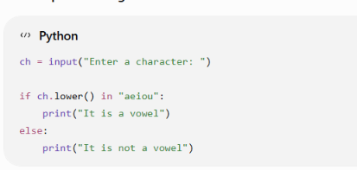

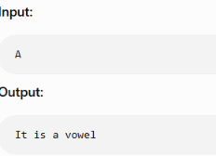

2.AI TOOL USED : gemini
PROMT: #generate a code to check whether a given word or letter is vowel or not
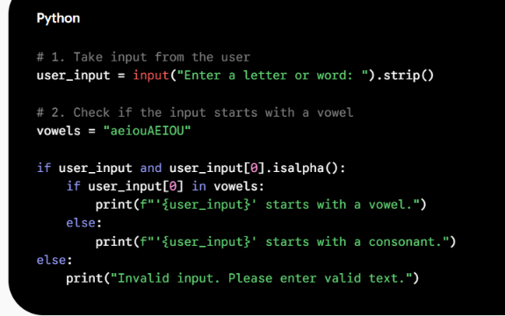
Output:
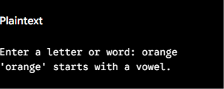
3.AI TOOL USED : qwen ai
PROMT#generate a code to check whether a given word or letter is vowel or not
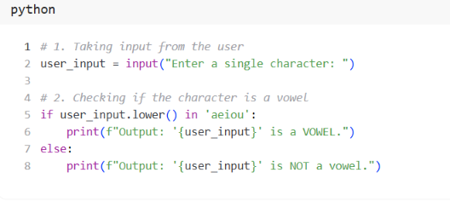

Output:

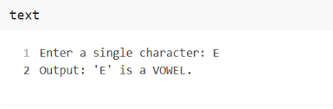
Comparison
Feature | Code 1 | Code 2 | Code 3
Checks a single character | ✅ | ❌ | ✅
Checks whether character is vowel | ✅ | ❌* | ✅
Checks first letter of word | ❌ | ✅ | ❌
Accepts words | Technically yes | ✅ | Technically yes
Input validation | ❌ | ✅ | ❌
Handles uppercase | ✅ | ✅ | ✅
Uses .lower() | ✅ | ❌ | ✅
Beginner-friendly | ⭐⭐⭐⭐ | ⭐⭐⭐ | ⭐⭐⭐⭐⭐
Code simplicity | ⭐⭐⭐⭐ | ⭐⭐⭐ | ⭐⭐⭐⭐⭐
Best for your original question | ✅ | ❌ | ✅

CONCLUSION
Among the three AI-generated codes, Code 2 is the best for our requirement because we need to work with words, not just single characters.
- Code 1 is mainly designed for checking a single character.
- Code 3 is also designed for checking a single character and is the simplest.
- Code 2 accepts a complete word and checks its first letter to determine whether the word starts with a vowel or consonant.
- Code 2 also includes input validation, making it more reliable.
Final choice: 🏆 Code 2
Example:
Apple → starts with a vowel
Banana → starts with a consonant
Therefore, Code 2 is the most suitable and practical choice when the input is a word.

